Store decoration
1. Overview
1.1 Store page and decoration
The store page is a unique display space for Temu sellers to display products and brands. In addition to the default store page styles, Temu also provides design tools so that sellers can personalize store pages. With editable sections that can be dragged and dropped, it's easy for sellers to get their store looking exactly how they want it to. ‘’
1.2 Sellers can achieve the following by editing the appearance of their store:
- Improved product display and a greater emphasis on sales events for better sales
- Increased dwell times and click-through rates through banners and attractive product displays
- Customized visuals for an emphasis on brands
1.3 Available styles
Temu currently allows sellers to modify the following elements: background images, category sections, product sections, video sections and banner sections. More designs and styles will be available in the future.
1.4 Compliance
You shall ensure that any logos, symbols, designs, images, videos, and text used in connection with your account and online store on Temu do not infringe on anyone else's intellectual property rights or violate any applicable laws. Temu reserves the right to remove visuals if they contain content that does not comply with laws, regulations, the Seller Services Agreement, or Temu Seller Rules.
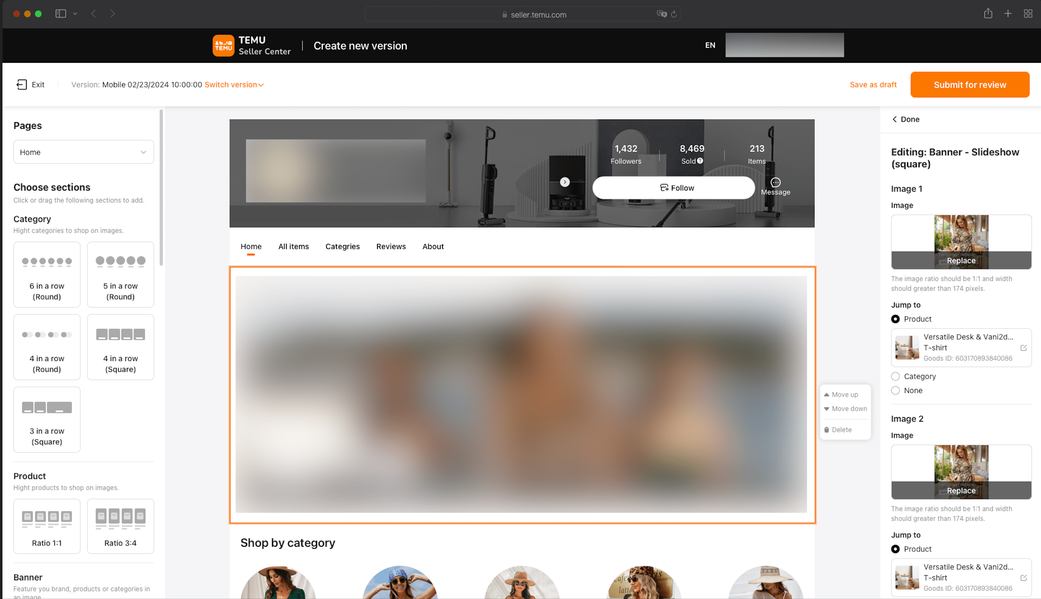
2.Decoration list page
2.1 Menu
Go to My account->Store decoration, enter the decoration list page, then agree to the Data Processing Agreement.
By default, only the main account has permission to store decoration. You can manage permissions by going to My account->User permissions.
2.2 Store decoration needs to be done separately on mobile and desktop.
Sellers can create multiple versions for mobile and desktop, but only one version can be in effect and visible for mobile and desktop at once. Temu will randomly check content that has been uploaded, and any decorations that fail the check cannot be published and will need to be changed.
2.3 Layout
When the number of versions is 0, it means that the list of decorations is empty and a new version can be created. When the number of versions is above 0, the page will show created versions, with a list of versions (including their statuses and actions that can be performed) on the left and a preview of the selected version on the right.
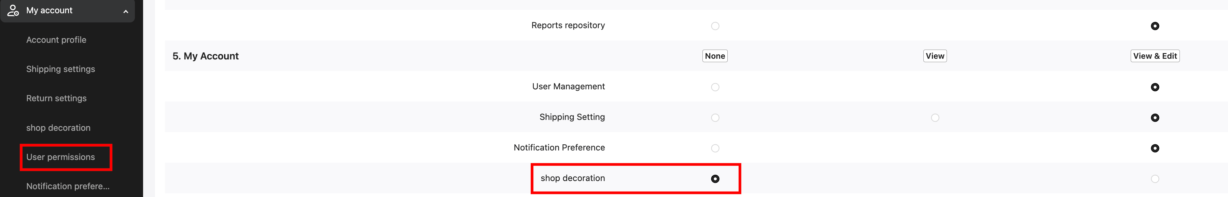
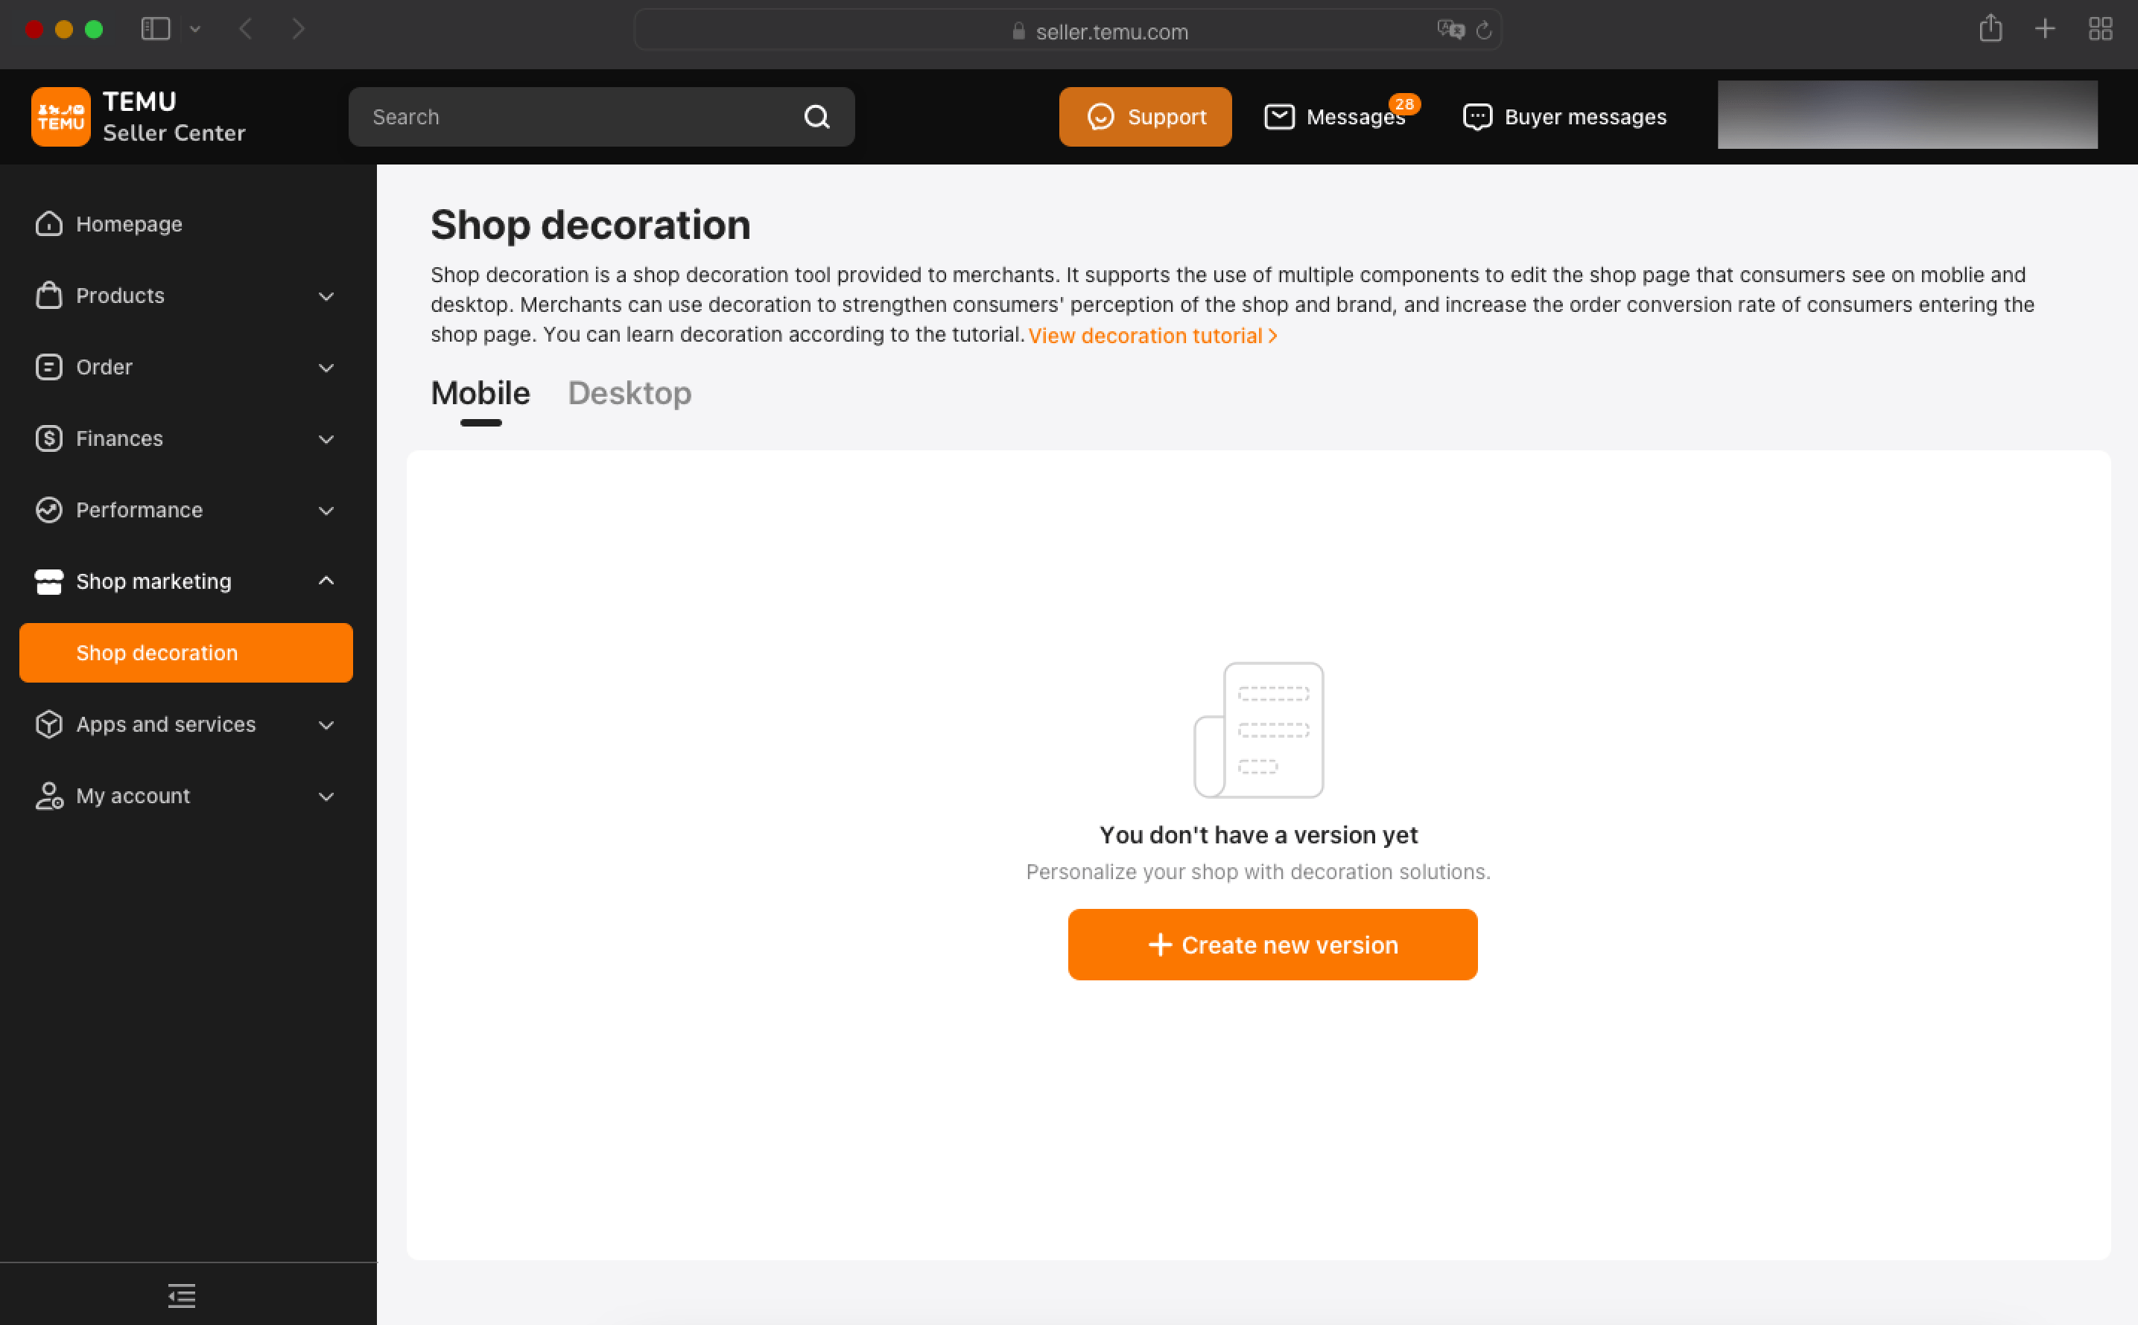
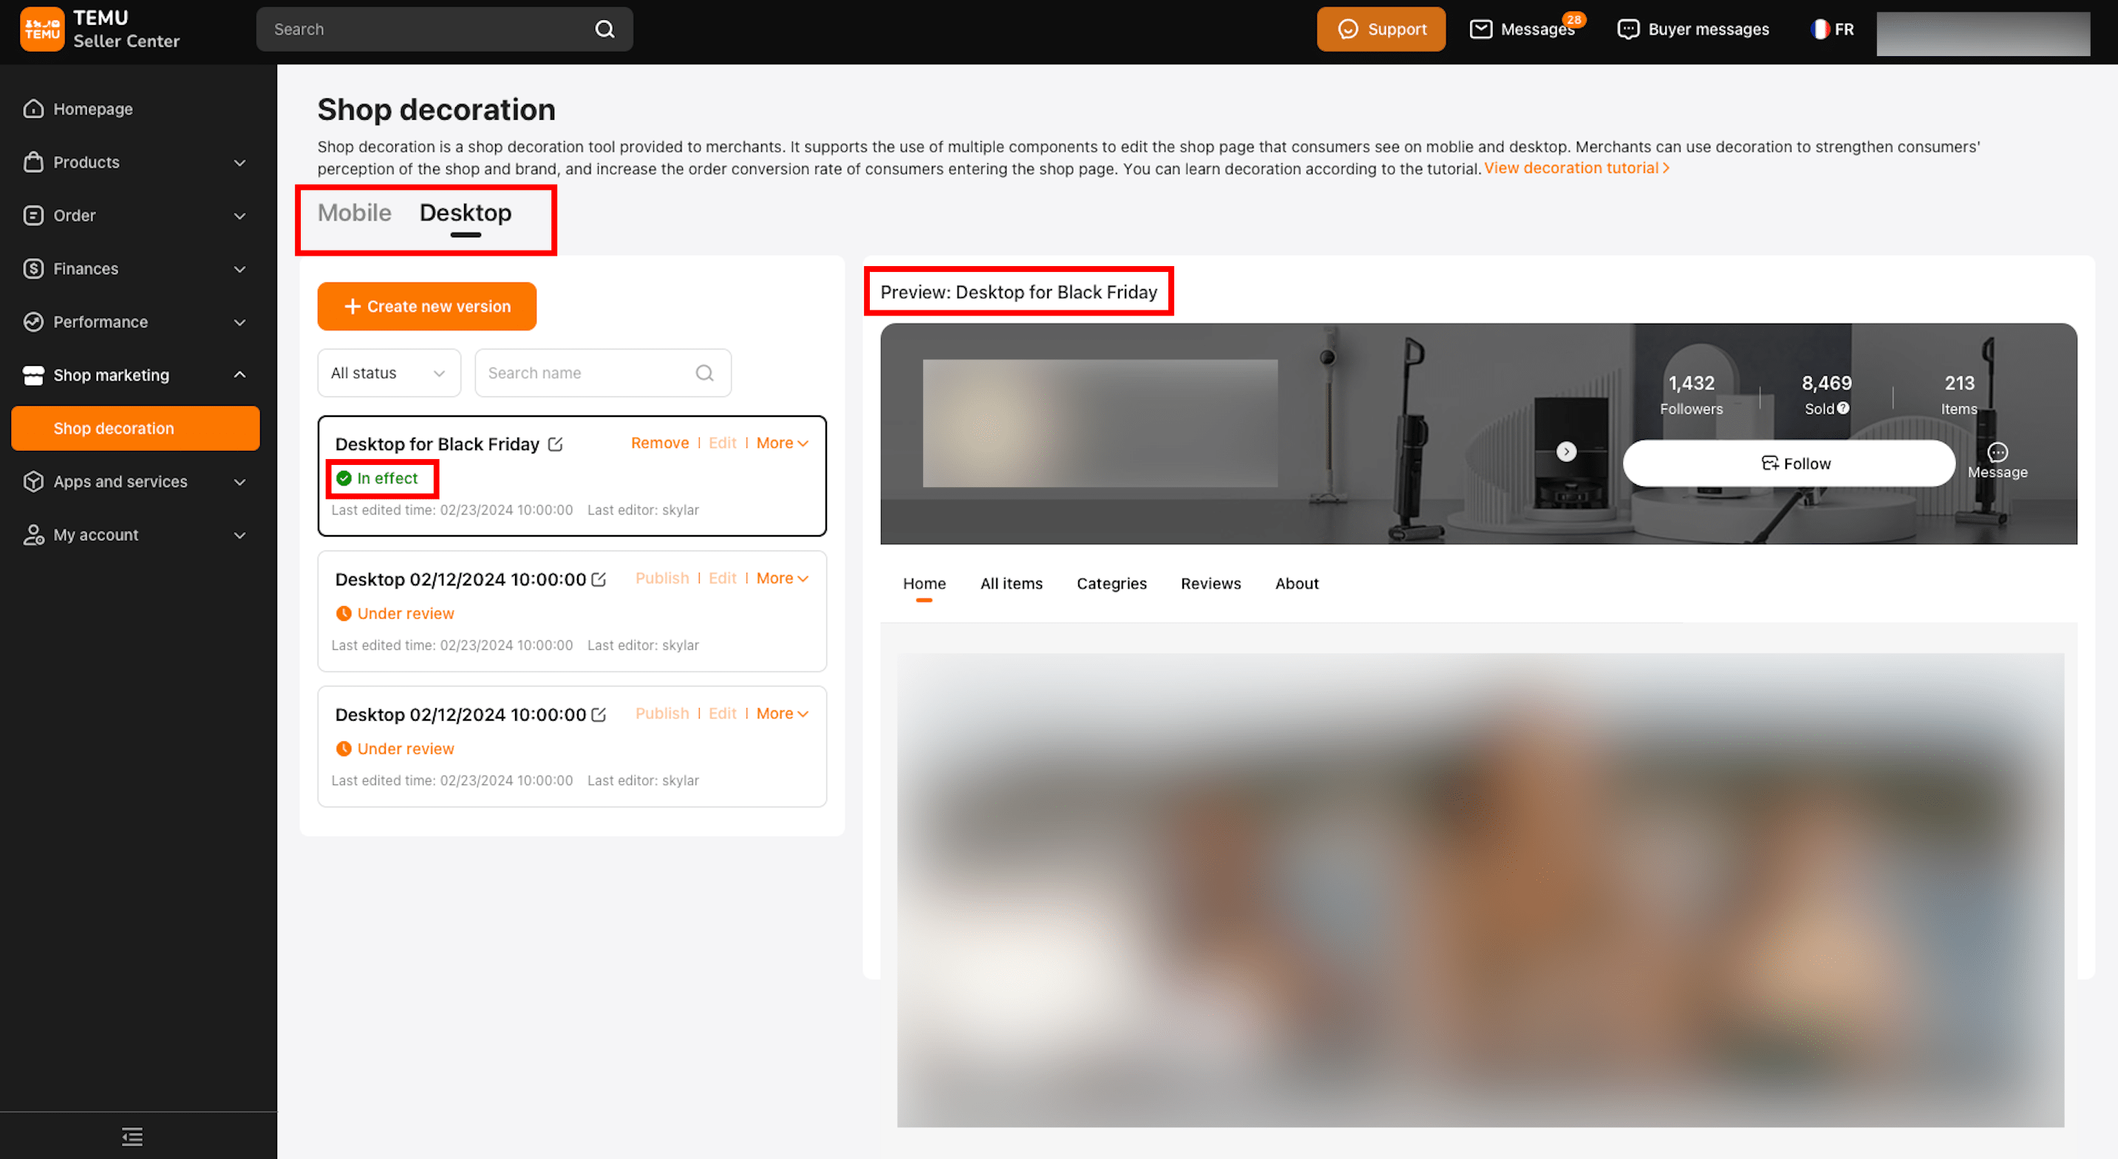
3.Decoration Edit Page
3.1 Section selection area
On the left side of the page is the section selection area, which contains all available decoration sections that can be dragged onto the canvas. (The background image above the canvas can be edited by clicking on the canvas background .)
3.2 Canvas
In the center of the page is the canvas, which displays how the sections are arranged and can be dragged and sorted.
3.3 Page layout and section editing area
On the right side of the page is the page layout and section editing area. By default, it shows the page structure. When a specific section on the canvas is selected, editing details are displayed, allowing you to add images and product lists. Please ensure that materials meet the specified dimensions.
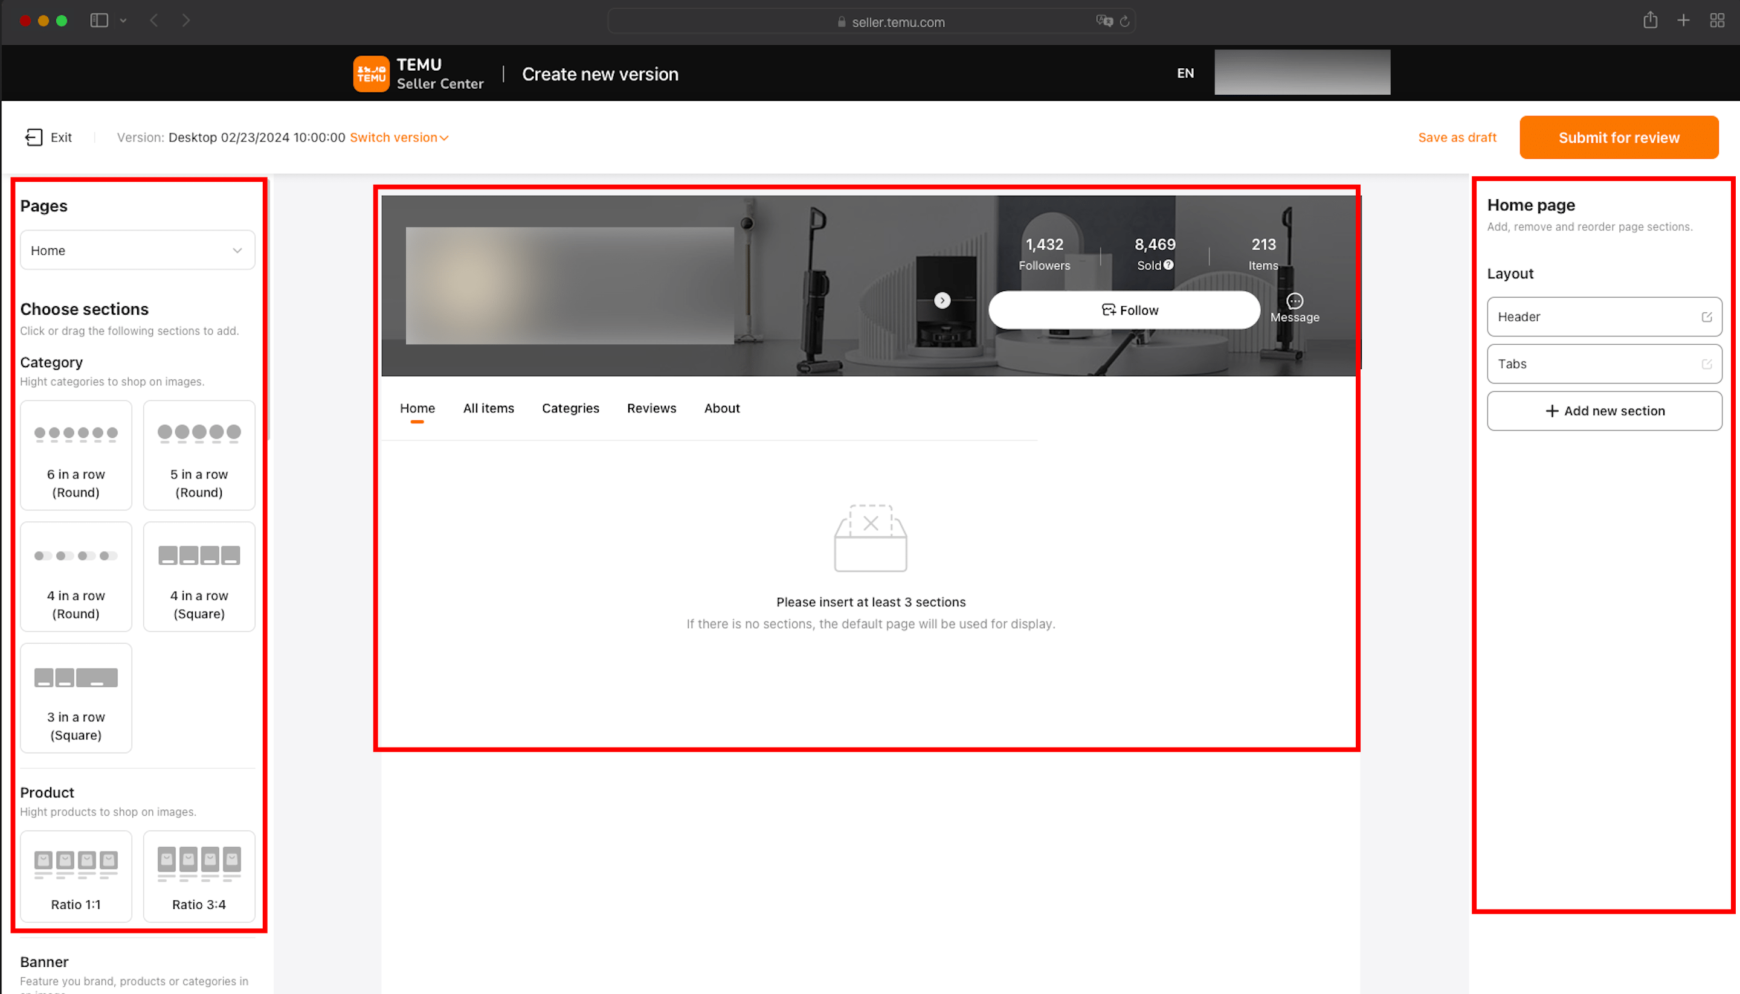
4.Submit and publish
4.1 When submitting a version:
A check will be automatically performed to detect if any required fields have been left empty. If so, you will be prompted by a red pop-up box with corresponding instructions for you to make changes.
4.2 The submitted decorations may encounter spot checks.
If the decoration version are not approved, it will not be able to publish.
4.3 If "Rejected" is displayed:
It indicates that the version you submitted were not approved. Please make corresponding changes based on the reasons provided.
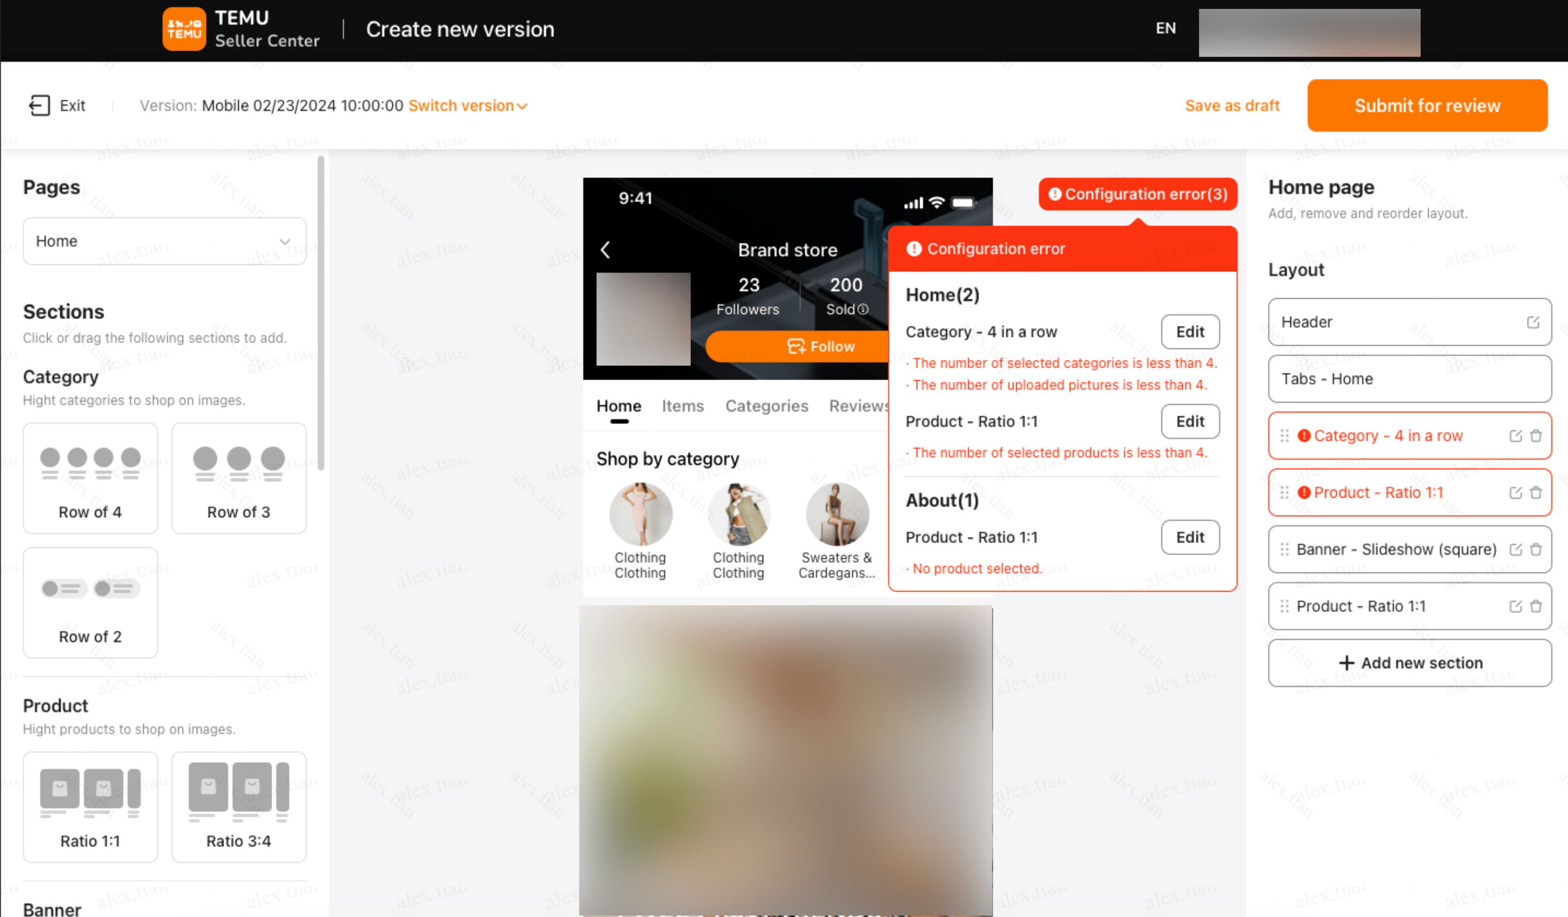
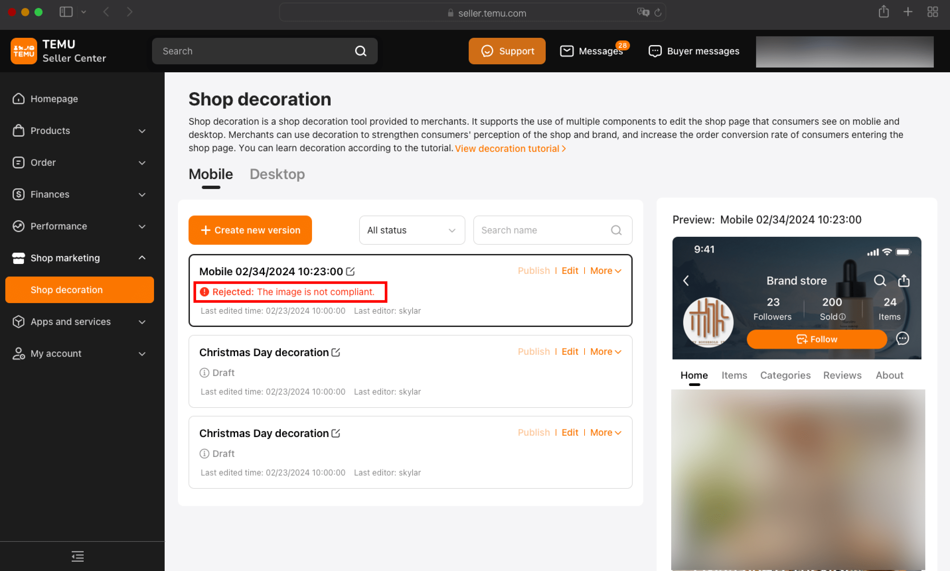
5.Frequently Asked Questions
5.1 Why do some buyers say they cannot see my home page and can only see the default version?
Please check whether the decoration you designed is in effect and your store has enough active products.
5.2 Why does Temu require 30 active products?
There is a correlation between how many active products a store has and the probability of the buyer purchasing something in the store page. If the store has a small number of products for sale, there is a lower probability of the buyer of making a purchase. In order to ensure that your store sells well, Temu will use the default decoration version when there are less than 30 products.
5.3 Why could some files not be uploaded?
Uploads may sometimes fail because of the network environment. You can try to upload the files later on. If there are no network issues but you are unable to upload the files successfully, please check whether the size or scale of the files meets the requirements.
